JAVA 8 ASSESMENT

1.Write the following a functional interface and implement it using lambda
(1.1) First number is greater than second number or not Parameter (int ,int ) Return boolean

Source Code:

@FunctionalInterface
interface Com{
boolean calci(int a,int b);
}
public class Ques1 {
public static void main(String[] args) {
Com c = (a,b)-> {
if(a>b)
return true;
else
return false;
};
boolean res = c.calci(10 , 9);
System.out.println(res);
}
}
Output:

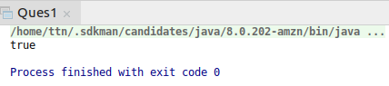

(1.2) Increment the number by 1 and return incremented value Parameter (int) Return int
Source Code:
@FunctionalInterface
interface Com{
int inc(int a);
}
public class Ques1 {
public static void main(String[] args) {
Com i = a-> ++a;
int res = i.inc(10);
System.out.println(res);
}
}
Output:
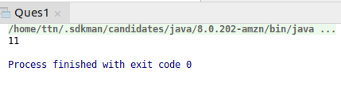

(1.3) Concatination of 2 string Parameter (String , String ) Return (String)
Source Code:
@FunctionalInterface
interface Com{
String cat(String a,String b);
}
public class Ques1 {
public static void main(String[] args) {
Com c =(a,b)-> a.concat(b);
String res;
res = c.cat("She","etal");
System.out.println(res);
}
}
Output:
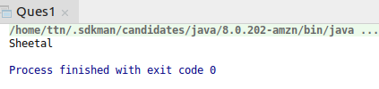

1.4) Convert a string to uppercase and return .Parameter (String) Return (String)
Source Code:
@FunctionalInterface
interface Com{
String up(String a);
}
public class Ques1 {
public static void main(String[] args) {
Com c =a-> a.toUpperCase();
String res;
res = c.up("sheetal");
System.out.println(res);
}
}
Output:
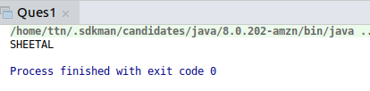

2.Create a functional interface whose method takes 2 integers and return one integer.
Source Code:
@FunctionalInterface
interface S{
int sum(int a,int b);
}
public class Ques2 {
public static void main(String[] args) {
S s = (a,b)-> a+b;
System.out.println(s.sum(12,45));
}
}
Output:
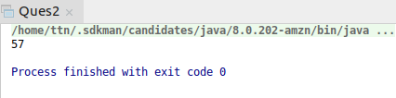

3.Using (instance) Method reference create and apply add and subtract method and using (Static) Method reference create and apply multiplication method for the functional interface created.

Source Code:
@FunctionalInterface
interface Comp{
int multiply(int a,int b);
}
public class Ques3 {
int sum(int a,int b){return a+b;};
int sub(int a,int b){return a-b;};
static int multiply(int a,int b){return a*b;}
public static void main(String[] args) {
Comp c = new Ques3()::sum;
System.out.println(c.multiply(10,5));
Comp c1 = new Ques3()::sub;
System.out.println(c1.multiply(10,5));
System.out.println(Ques3.multiply(10,5));
}
}
Output:
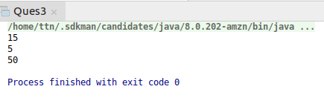

4.Create an Employee Class with instance variables (String) name, (Integer)age, (String)city and get the instance of the Class using constructor reference
Source Code:
class Employee{
String name;
int age;
String city;
@Override
public String toString() {
return "Employee{" +
"name='" + name + '\'' +
", age=" + age +
", city='" + city + '\'' +
'}';
}
public Employee(String name, int age, String city)
{
this.name = name;
this.age = age;
this.city = city;
}
}
interface Emp{
Employee employeerefrence(String name,int age,String city);
}
public class Ques4{
public static void main(String[] args) {
Emp e = Employee::new;
Employee obj = e.employeerefrence("sheetal", 21, "ghaziabad");
System.out.println(obj.toString());
Employee obj1 = e.employeerefrence("Arpit", 16, "noida");
System.out.println(obj1.toString());
}
}
Output:
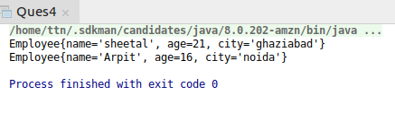

4.Implement following functional interfaces from java.util.function using lambdas:
- (1) Consumer
- (2) Supplier
- (3) Predicate
- (4) Function

Source Code:
import java.util.function.Consumer;
import java.util.function.Function;
import java.util.function.Predicate;
import java.util.function.Supplier;
public class Ques5 {
public static void main(String[] args) {
//Consumer
Consumer<String> consumer = s-> System.out.println(s);
consumer.accept("Sheetal");
//Supplier
Supplier<String> supplier = ()->"Supplier interface";
System.out.println( supplier.get());
//Predicate
Predicate<String> predicate = p->p.isEmpty();
System.out.println(predicate.test("abc"));
//Function
Function<Integer,Integer> function = (f)-> f>5 ? ++f : --f;
System.out.println(function.apply(2));
}
}
Output:
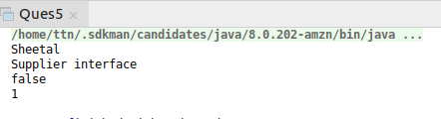

6.Create and access default and static method of an interface.
Source Code:
interface Example{
static void hi(){
System.out.println("static hi");
}
default void hey(){
System.out.println("default hey");
}
}
public class Ques6 implements Example {
public static void main(String[] args) {
Ques6 q = new Ques6();
Example.hi();
q.hey();
}
}
Output:
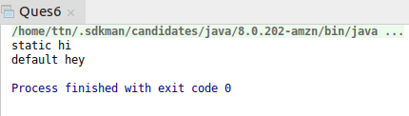

7.Override the default method of the interface.
Source Code:
interface Eg{
default void hello(){
System.out.println("default hi");
}
}
public class Ques7 implements Eg {
@Override
public void hello()
{
System.out.println("default hello");
}
public static void main(String[] args) {
Ques7 q = new Ques7();
q.hello();
}
}
Output:
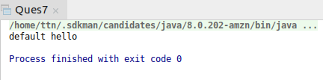

8.Implement multiple inheritance with default method inside interface.
Source Code:
interface Demo{
default void up(){
System.out.println("hello-up");
}
}
interface Demo1{
default void down(){
System.out.println("hello-down");
}
}
interface Demo2 extends Demo,Demo1{
}
public class Ques8 implements Demo2 {
public static void main(String[] args) {
Ques8 q = new Ques8();
q.down();
q.up();
}
}
Output:
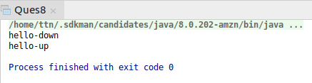

9.Collect all the even numbers from an integer list
Source Code:
import java.util.ArrayList;
import java.util.Arrays;
import java.util.List;
import java.util.stream.Collectors;
public class Ques9 {
public static void main(String[] args) {
Integer[] arr = {23,46,67,34,24,12,89};
List<Integer> list = Arrays.asList(arr);
List<Integer> result = list.stream().filter(e->e%2==0).collect(Collectors.toList());
result.forEach(System.out::println);
}
}
Output:
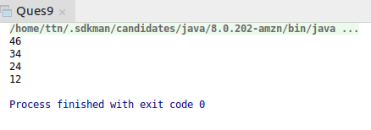

10.Sum all the numbers greater than 5 in the integer list.
Source Code:
import java.util.Arrays;
import java.util.List;
public class Ques10 {
public static void main(String[] args) {
Integer[] arr = {10,5,0,2,13,14,50};
List<Integer> list = Arrays.asList(arr);
int result = list.stream().filter(i->i>5).reduce(0,(a,b)->a+b);
System.out.println("The sum is:"+result);
}
}
Output:
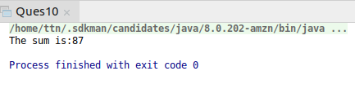

11.Find average of the number inside integer list after doubling it
Source Code:
import java.util.Arrays;
import java.util.Collections;
import java.util.List;
public class Ques11 {
public static void main(String[] args) {
Integer[] arr = {2,4,6,1,3};
List<Integer> list = Arrays.asList(arr);
double avg = list.stream().mapToInt(i->i*2).average().getAsDouble();
System.out.println("The average is: " + avg);
}
}
Output:
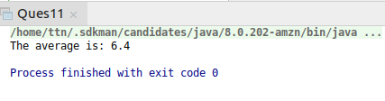

12.Find the first even number in the integer list which is greater than
Source Code:
import java.util.Arrays;
import java.util.List;
import java.util.NoSuchElementException;
public class Ques12 {
public static void main(String[] args) {
Integer[] arr={1,5,4,3,10};
List<Integer> list = Arrays.asList(arr);
try {
int res = list.stream().filter(i->i>3 && i%2==0).findFirst().get();
System.out.println(res);
} catch (NoSuchElementException e) {
System.out.println("No element found in this list");
}
}
}
Output:
